Chapter 14, Solution 82.

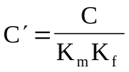

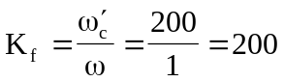

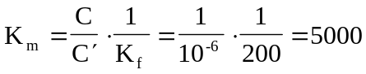

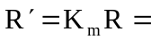5 kΩ, thus, 